**Project Design Phase-II**

**Technology Stack (Architecture & Stack)**

|  |  |
| --- | --- |
| Date | 03 November 2022 |
| Team ID | PNT2022TMID52669 |
| Project Name | News Tracker Application |
| Maximum Marks | 4 Marks |

**Technical Architecture:**

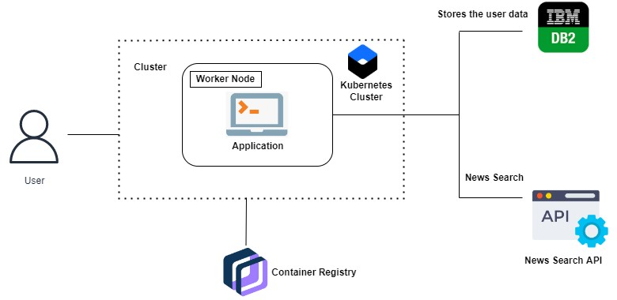

**Table 1: Components & Technologies:**

|  |  |  |  |
| --- | --- | --- | --- |
| **S.No** | **Component** | **Description** | **Technology** |
| 1. | User Interface | The user can interact with the application to know about the trending news | HTML,CSS,  JavaScript/  Angular Js/ React  Js etc. |
| 2. | Application  Logic-1 | The application contains this resource gives you basic understanding of Flask | Flask |
| 3. | Application  Logic-2 | The application contains the news subdivision like geographical news, economic news and society news | IBM Watson STT  service |
| 4. | Application  Logic-3 | The user can view the growth of the economy in industry through graph | IBM Watson  Assistant |
| 5. | Database | Updation of trending news are stored in the  MySQL database | MySQL, NoSQL, etc. |
| 6. | Cloud  Database | With the use of cloud, media coverage issue cannot be occurred | IBM DB2, IBM  Cloudant etc. |

**Table 2: Application Characteristics:**

|  |  |  |  |
| --- | --- | --- | --- |
| **S.No** | **Characteristics** | **Description** | **Technology** |
| 1. | Open-Source  Frameworks | Flask is flexible and doesn’t require to use any particular project or code  layout used in this application | Python-Flask |
| 2. | Security  Implementations | This can be access only by the journalist. So, It is a high Security | Container Registry, Kubernetes Cluster. |
| 3. | Scalable  Architecture | News Tracker is a socio-economic access because helps to know about the daily activity of the world | Container Registry, Kubernetes Cluster. |
| 4. | Availability | This application will be available to the all the user who are using this application | Container Registry, Kubernetes Cluster. |
| 5. | Performance | The updation of trending news occurs without any interruption. So, it performance is good | Kubernetes Cluster. |

**References:** <https://github.com/IBM-EPBL/Assignments-CApD/tree/main><https://ieeexplore.ieee.org/document/5616930><https://ieeexplore.ieee.org/document/1565880><https://ieeexplore.ieee.org/document/8703401>